Nkhensile Mthombeni

ST10477539

MY MUSIC APP

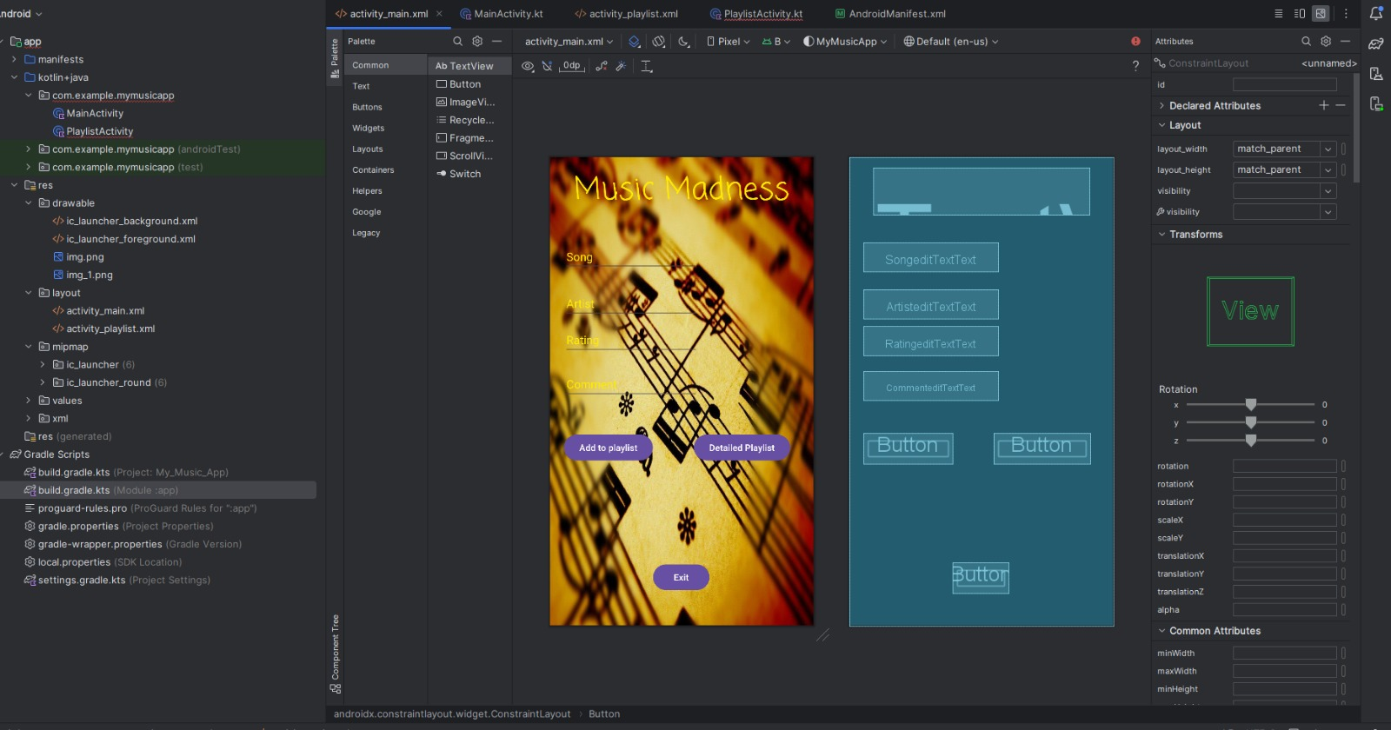

This is the layout of the main activity

It has three buttons, add playlist button, next button and exit button

I have added a music background to make it look more appealing

This is the second part of the code as you can see here

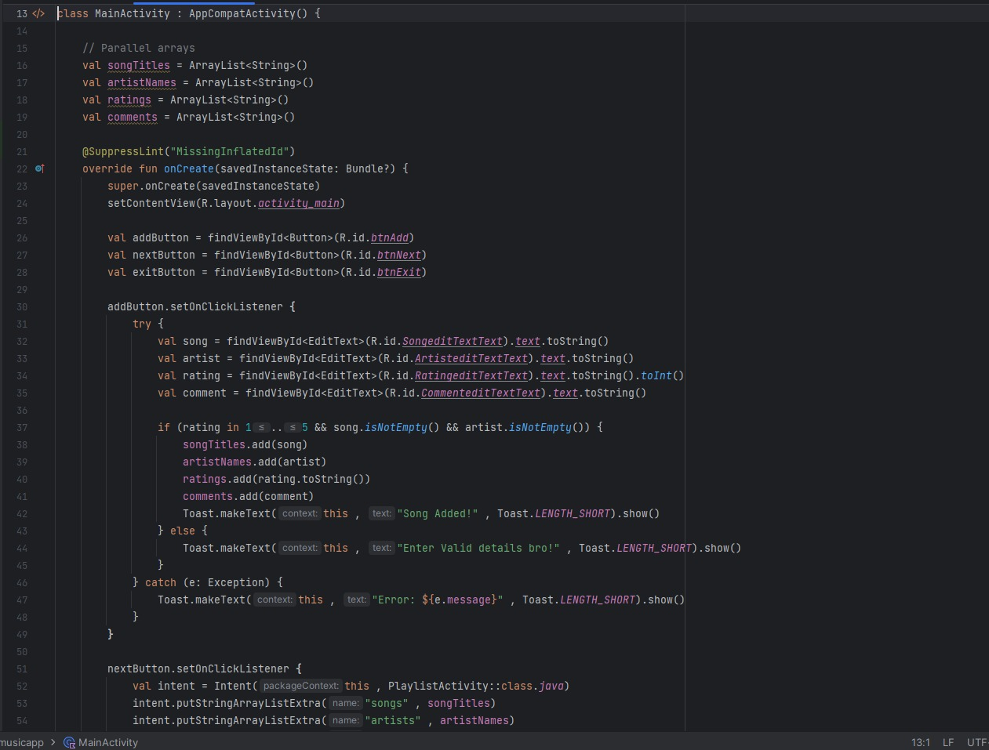

This is the first part of the code

The is the second screen

It has two buttons, the average and back button

This is the code for the second screen

This is the UL layout

Github link: [NkhensileMthombeni/Exam: Practium Exam](https://github.com/NkhensileMthombeni/Exam)